1 Given the provided data, what are three conclusions that we can draw about crowdfunding campaigns?

* Of the project categories with a statistically significant number of projects (ie, excluding journalism), Technology projects were the most likely to succeed with a 66.7% success rate. Games were the least likely to succeed with just 43.8% though there were comparatively fewer of them (96 vs 48 respectively).
* From the 1,000 projects listed, those started in the UK had a marginally higher success rate than the average (58.33% vs 56.50% respectively) though in all jurisdictions the success rate is broadly similar in the mid 50s.
* All else being equal, food projects took in the highest average donation (72.22) while photography projects took in the lowest (46.41). Once again excluding journalism.
* Theater projects have consistently been the most common category reaching a nadir of 22.62% in 2012 though remaining the most common category in that year.

2 What are some limitations of this dataset?

* We have no data for how far into each campaign donations were received. For example, a common tactic is for a crowdfunding creator to make a large initial ‘donation’ to create the appearance of an initial level of support. We also have no indication whether donations were received continuously throughout the campaign or in concentrated time periods, i.e. as the result of a marketing push.
* We don’t have information for exchange rates at the time of donation/success. For example at times in 2010 the AUD was worth as much as 1.10 USD while in early 2020 the exchange rate fell as low as 0.57x. This makes it more difficult to judge the relative success of projects as a function of time or in comparison to their equivalents in other countries.
* We have no insight into individual donors. For example, one individual may make several donations while an equivalent donor may match the sum of those in a single donation.

3 What are some other possible tables and/or graphs that we could create, and what additional value would they provide?

* Histogram showing the percentage of each campaign’s goal. This shows us the long right-hand tail indicating that relatively few successful projects get funded up to their goal and no further, while many successful projects are funded several times in excess of their stated goal.

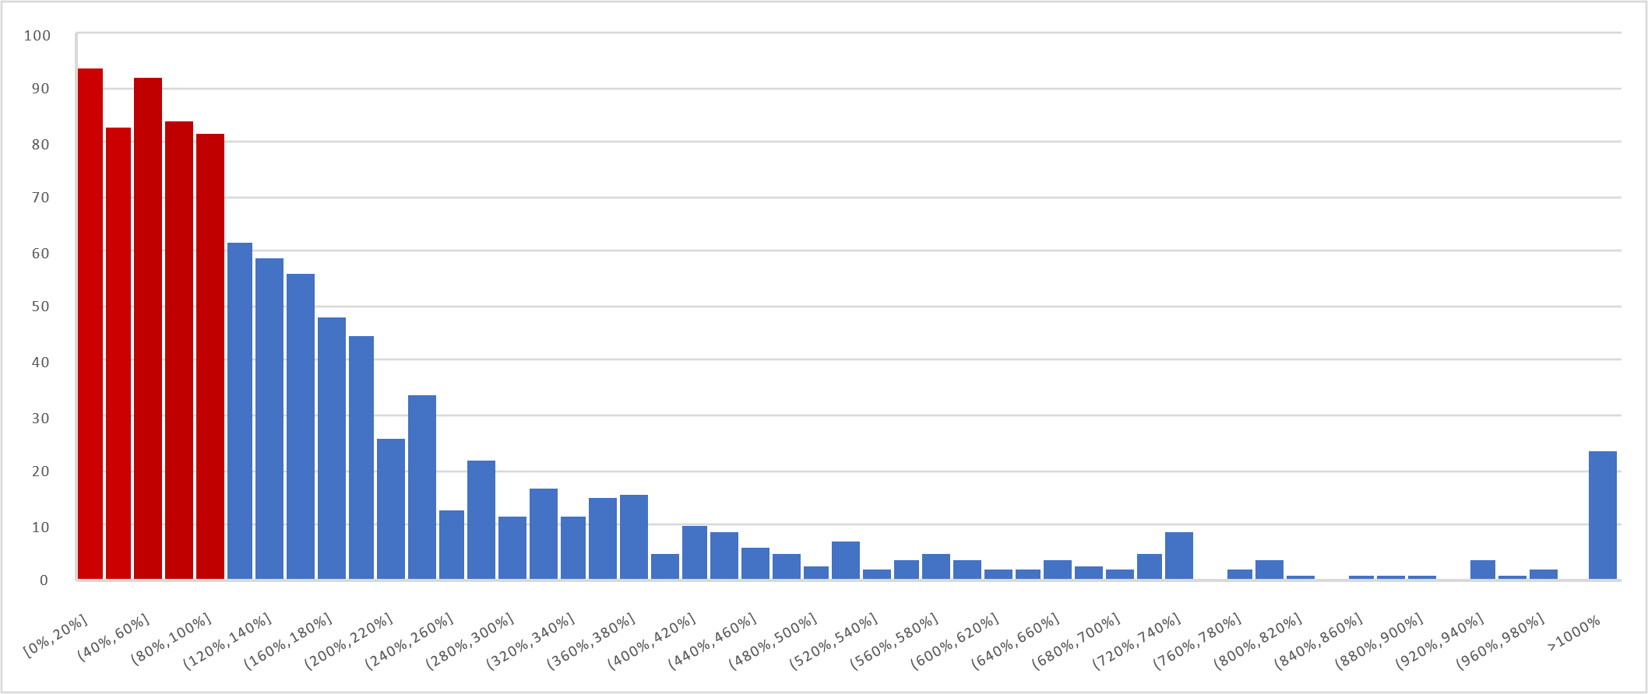

* Table showing the relative percentage of projects in each major category, divided by year supporting conclusion 4 from question 1.

|  |  |  |  |  |  |  |  |  |  |
| --- | --- | --- | --- | --- | --- | --- | --- | --- | --- |
| Year \ Category | food | music | technology | theater | film & video | publishing | games | photography | journalism |
| 2010 | 1.85% | 19.44% | 7.41% | 39.81% | 11.11% | 9.26% | 4.63% | 6.48% | 0.00% |
| 2011 | 5.83% | 20.39% | 5.83% | 32.04% | 25.24% | 3.88% | 2.91% | 3.88% | 0.00% |
| 2012 | 4.76% | 16.67% | 15.48% | 22.62% | 19.05% | 9.52% | 7.14% | 4.76% | 0.00% |
| 2013 | 3.41% | 13.64% | 13.64% | 36.36% | 15.91% | 5.68% | 7.95% | 3.41% | 0.00% |
| 2014 | 2.94% | 19.61% | 8.82% | 30.39% | 16.67% | 8.82% | 5.88% | 4.90% | 1.96% |
| 2015 | 2.86% | 16.19% | 13.33% | 32.38% | 18.10% | 6.67% | 6.67% | 3.81% | 0.00% |
| 2016 | 6.12% | 19.39% | 10.20% | 34.69% | 17.35% | 6.12% | 4.08% | 2.04% | 0.00% |
| 2017 | 6.93% | 13.86% | 6.93% | 40.59% | 19.80% | 3.96% | 3.96% | 3.96% | 0.00% |
| 2018 | 5.88% | 21.57% | 8.82% | 33.33% | 18.63% | 6.86% | 0.98% | 3.92% | 0.00% |
| 2019 | 5.61% | 13.08% | 7.48% | 39.25% | 16.82% | 6.54% | 4.67% | 4.67% | 1.87% |
| 2020 | 0.00% | 50.00% | 0.00% | 50.00% | 0.00% | 0.00% | 0.00% | 0.00% | 0.00% |

* Table showing the count for each outcome and success rate by country, supporting conclusion 3 from question 1.

|  |  |  |  |  |  |
| --- | --- | --- | --- | --- | --- |
| Country \ Outcome | Successful | Failed | Canceled | Live | Success Rate |
| CA | 22 | 19 | 2 | 1 | 50.00% |
| US | 436 | 274 | 44 | 9 | 57.14% |
| AU | 24 | 16 | 2 | 1 | 55.81% |
| DK | 17 | 12 | 1 | 1 | 54.84% |
| GB | 28 | 18 | 1 | 1 | 58.33% |
| CH | 12 | 6 | 4 | 1 | 52.17% |
| IT | 26 | 19 | 3 | 0 | 54.17% |
| Total | 565 | 364 | 57 | 14 | 56.50% |